**Pac-Man**

By Alex Mollard

# Objective:

The objective of Pacman is for the player to get as many points as possible with out being eaten by ghost.

# General Artificial Intelligence:

All ghost you a path finding algorithm called A* which is a improved version of Dijkstra’s algorithm where the scene has a grid which is full of nodes and the algorithm will use these nodes to find a path to the target node using the least amount of nodes possible but with A* it give the algorithm a direction to head towards instead of randomly searching around like Dijkstra’s.

# Ghost 1 (Wander, Cyan):

This ghost uses A* like all ghost but does not target the player but instead targets random nodes on the map.

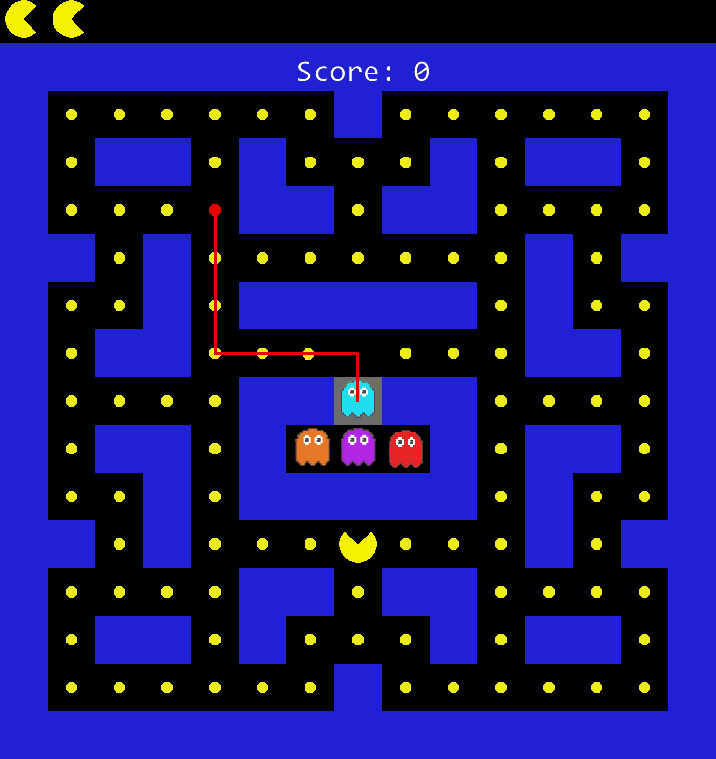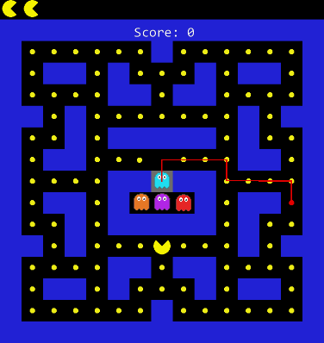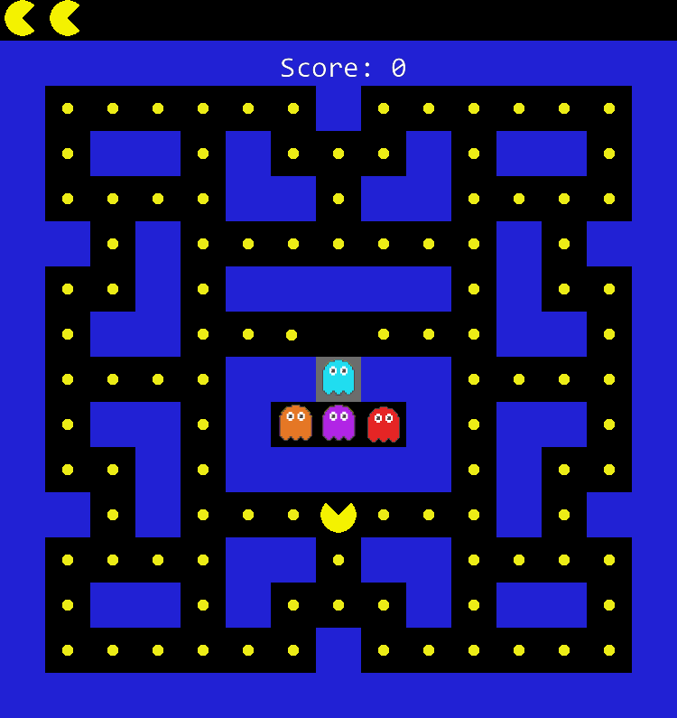

# Ghost 2 (Pursue, Purple):

This ghost uses A* like all ghost but targets the players position on the map every frame.

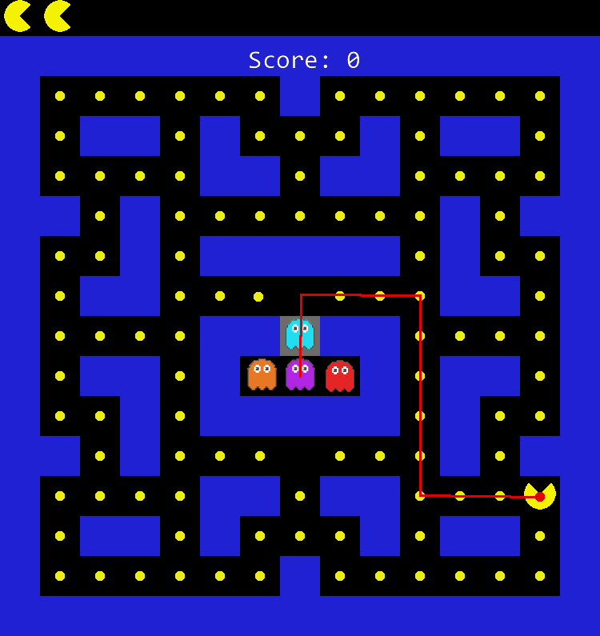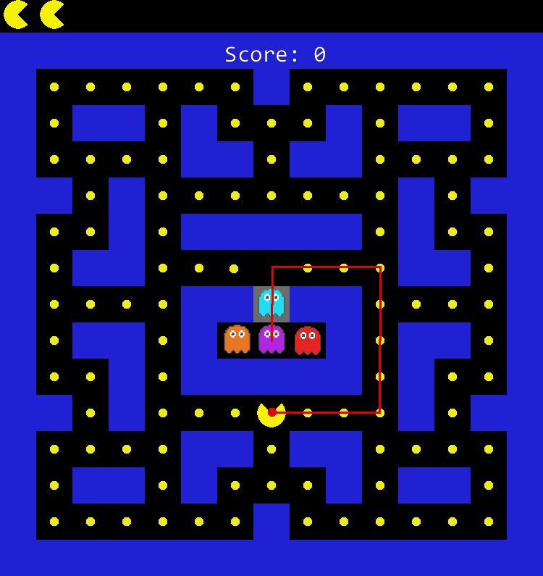

# Ghost 3 (Ambush, Red):

This ghost uses A* like all ghost but targets the players destination on the map every frame.

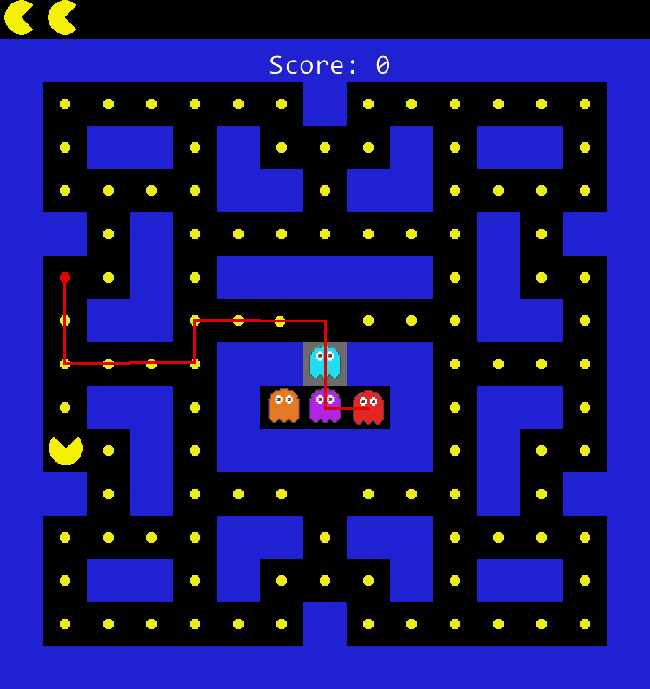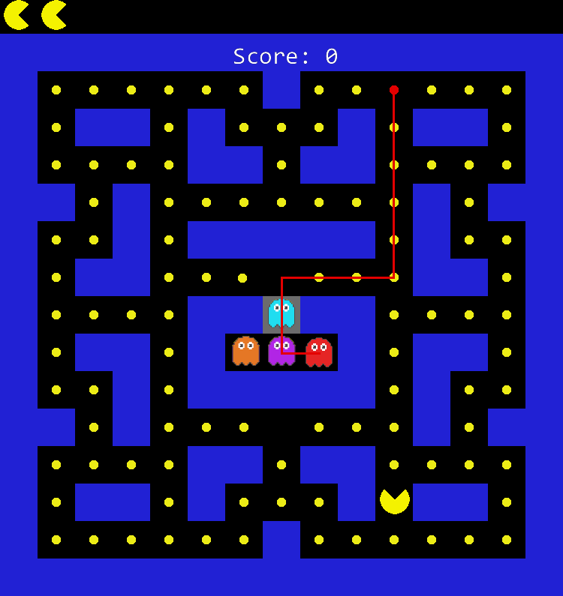

# Ghost 4 (Scared, Orange):

This ghost uses a combination of both the purple and cyan ghost as the ghost will pursue the player until it is one node away from then it will find a random node and target that node, once it has hit that node it will then try follow pacman yet again.

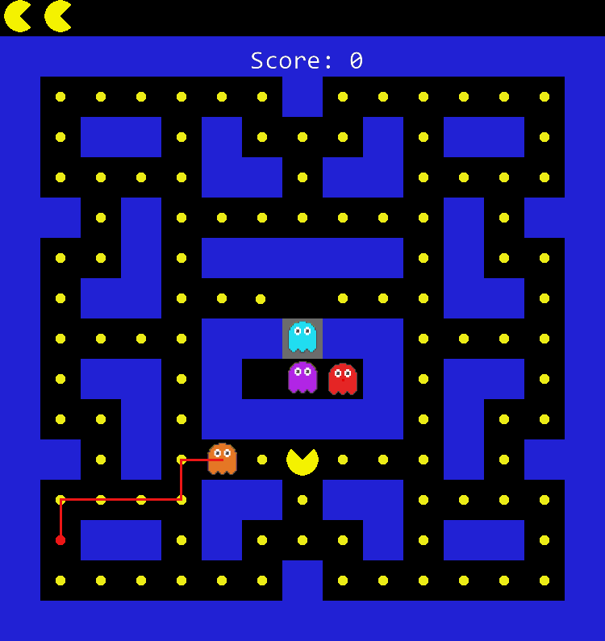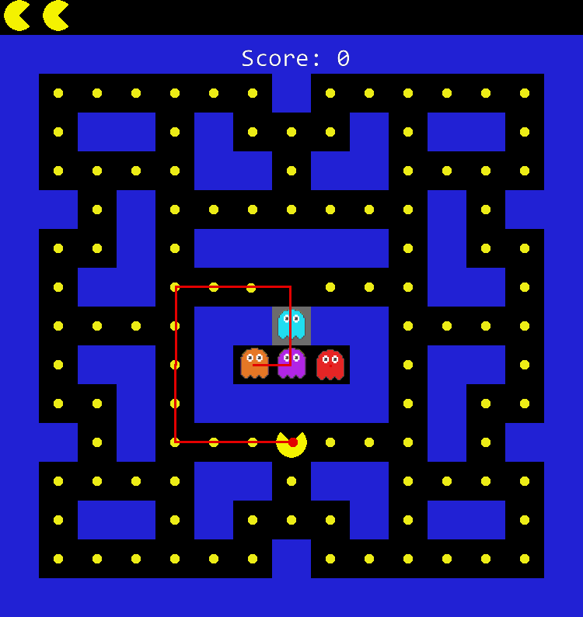This behavior can be unpredictable as sometimes the ghost will pick a random node that is in front of the player meaning you could expect it to run away but instead it will run straight into you or could even trap you like the red ghost tries to do.

# All Ghost (Flee):

All ghost have a state that allows them to stop chasing pacman and use the random node state that the cyan ghost uses.

This is put in place so that when the ghost is vulnerable they don’t just run into you.

